**Assignment day 5**

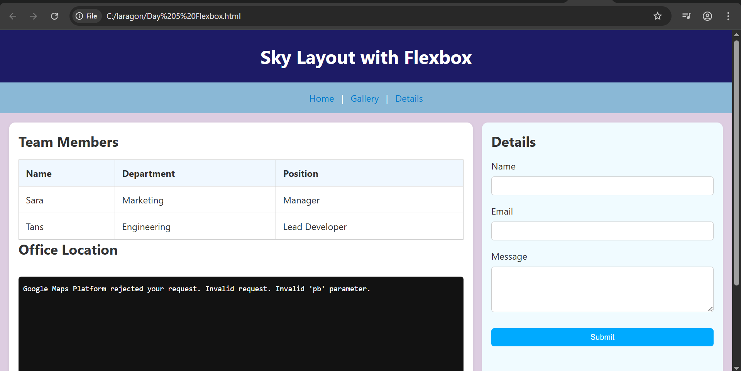

This is a responsive webpage built with HTML and CSS Flexbox. It includes a header, navigation bar, two-column layout, and footer. A table, contact form, and embedded map are added to show how different elements work together. The layout is styled with reusable CSS classes and adjusts well on all screen sizes using semantic HTML5 tags.